# POWER OF ATTORNEY: GRANTING, CHANGING AND CANCELLING

The Transport Administration e-service address is: <https://eteenindus.mnt.ee/main.jsf?lang=en>

In Transport Administration e-service You can grant a power of attorney for vehicle transactions and for receiving documents. The power of attorney can be granted for one specific vehicle separately or for transactions with all vehicles registered in the name of a natural or legal person at the same time.

Only the vehicle owner or his representative (authorized by e-service) can grant a power of attorney at e-service.

The power of attorney issued in the e-service is valid in the e-service and at Transport Administration bureau.

step i: entering e-service

In order to use the Transport Administration services please log in to the e-service by clicking "ENTER" (right top corner). You can enter the e-service with an ID-card, Mobile-ID or Smart-ID.

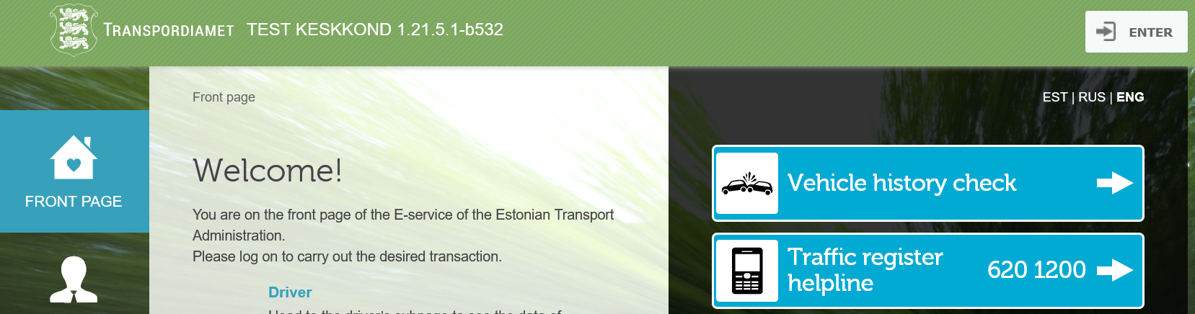

step ii: review and authorization

To view and grant the power of attorney, click "Authorizations" at the e-service front page.

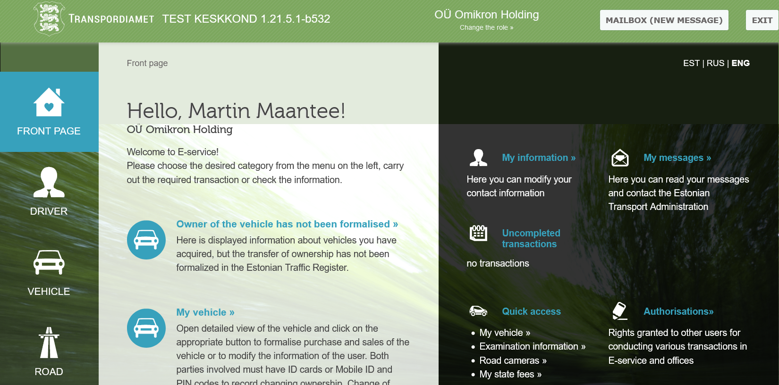

You will get a review of all the authorizations You have been given and that were granted by You to others.

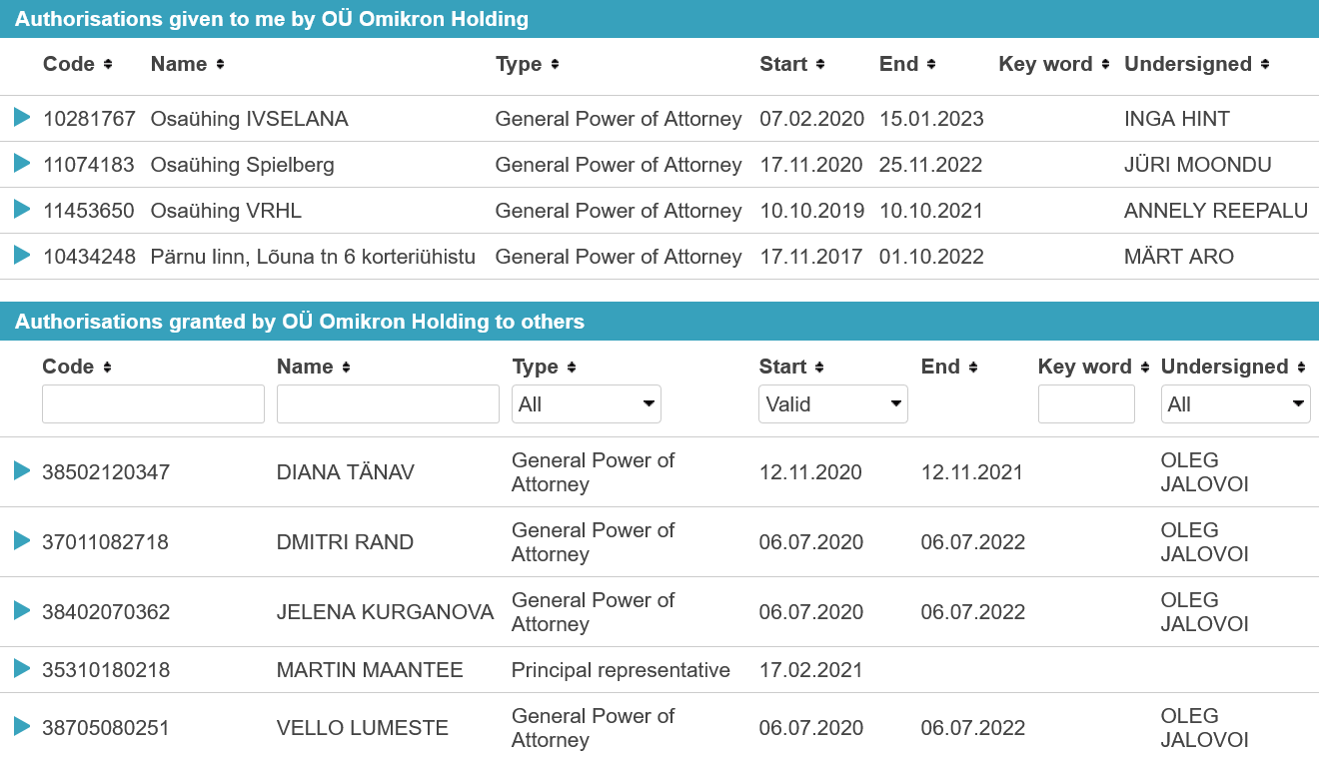

step iii: granting the power of attorney

To grant a power of attorney, click "New power of attorney", which will take you to the authorization page. You should know the personal or commercial code of the (legal) person whom You are going to grant rights.

When granting a power of attorney, You should also mark the period of validity. The maximum period of validity is 5 years. The quick access also includes 2 weeks, 1 month, 3 months, 6 months, 1 year and 2 years.

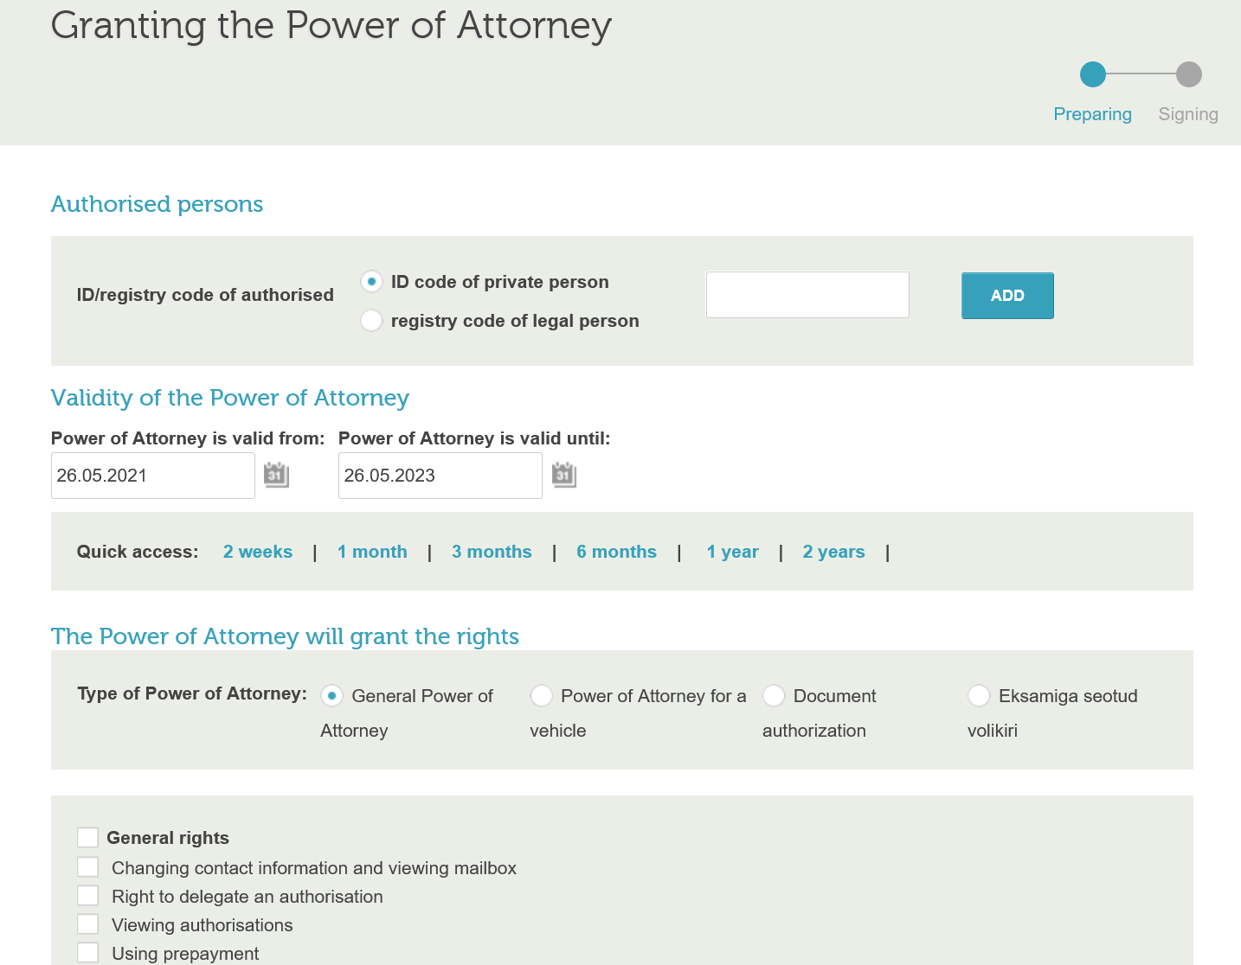

step iv: choosing the type of power of attorney

After the validity is marked, You should choose the type. There are three groups of authorizations:

1) General power of attorney: In the case of a general authorization, the authorized person may perform operations with all granted rights and vehicles.

2) Power of attorney for a vehicle: In the case of a vehicle authorization, You grant the right to perform operations with one specific vehicle.

3) Document authorization: The power of attorney for documents gives the right to receive documents related to the right to drive and to receive vehicle registration plate and certificates at the Transport Administration bureau.

GENERAL POWER OF ATTORNEY

In the case of a general power of attorney, the authorized person may perform operations with all granted rights and vehicles. The new general power of attorney will invalidate all previously granted general powers of attorney, while having no effects on powers of attorney related to specific vehicles. In order to issue a general power of attorney, the appropriate rights must be ticked and then the selection must be confirmed.

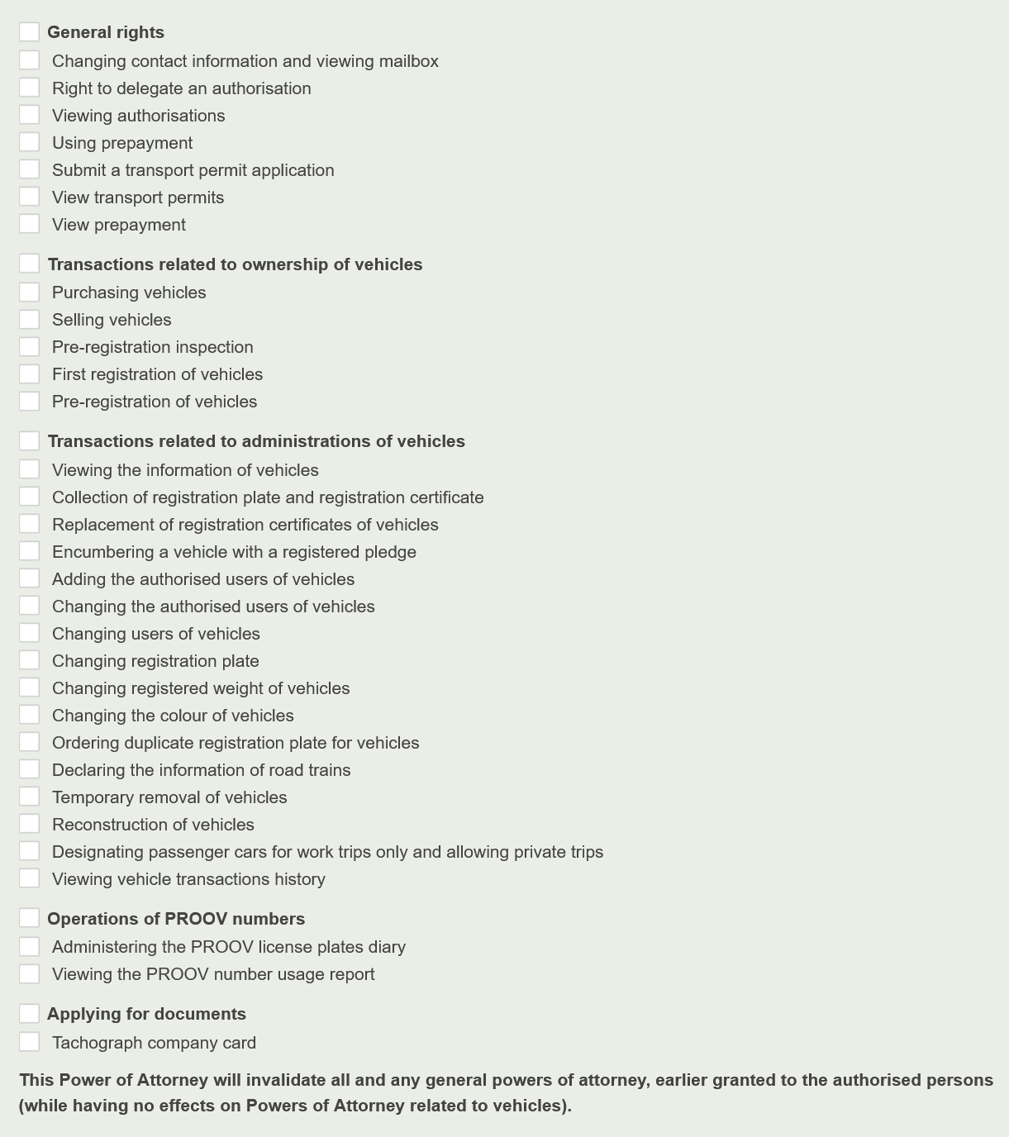

In case of a legal person, only the management board members have the right to grant powers of attorney. Having a right to delegate, a management board member can grant his employee a right to give authorizations, which means that in future all authorizations may also be granted by this employee. Thus, it is not always necessary to wait for a management board member to sign the powers of attorney.

POWER OF ATTORNEY FOR A VEHICLE

To issue a vehicle power of attorney, you must first choose the exact vehicle. For that You need to enter the vehicle registration number or the VIN code.

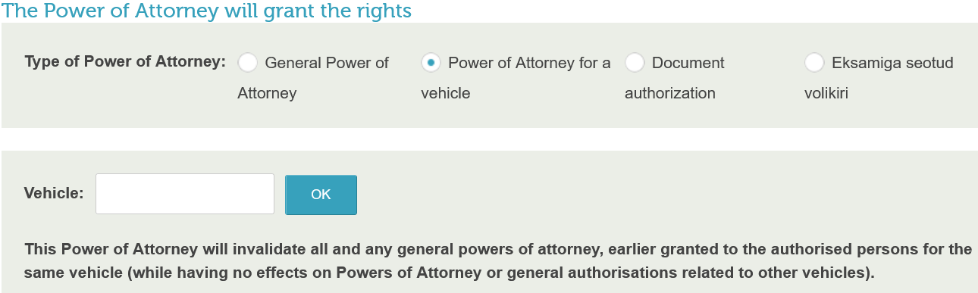

The power of attorney for a vehicle grants the right to perform actions related to one specific vehicle. If You issue a new vehicle power of attorney, the previously granted authorizations for this person in the connection with the same vehicle will become invalid, however, it will not affect the power of attorneys related to other vehicles or general authorizations. The appropriate rights must be ticked and then the selection should be confirmed.

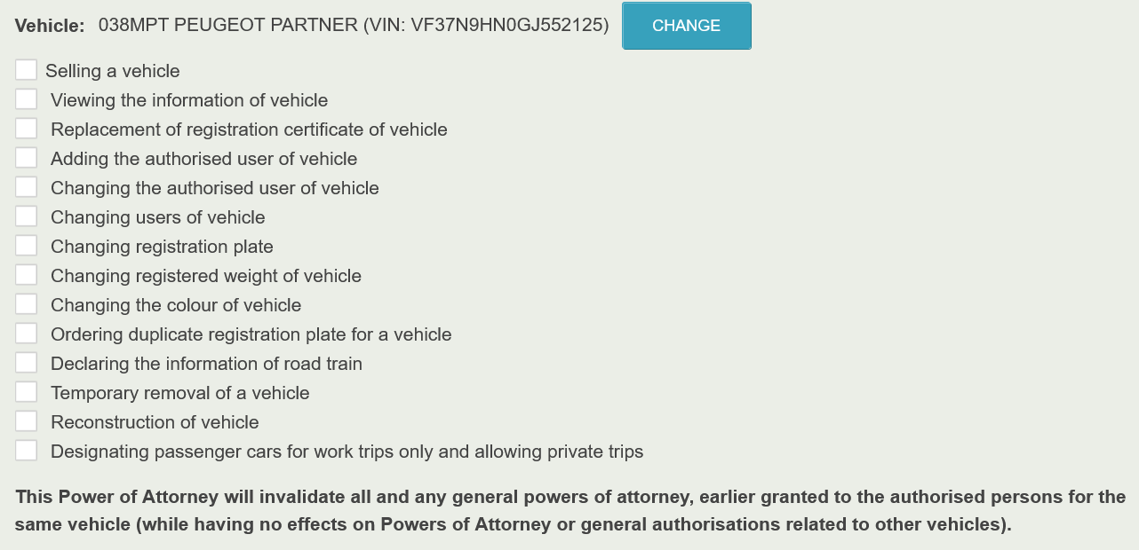

In the case of a vehicle power of attorney, natural and legal persons have the same rights.

DOCUMENT AUTHORIZATION

The power of attorney for documents gives the right to receive documents related to the right to drive and the vehicle registration plate and certificates at Transport Administration bureau. You can give a power of attorney for documents only to a natural person by entering his personal code.

A legal person can grant the following rights

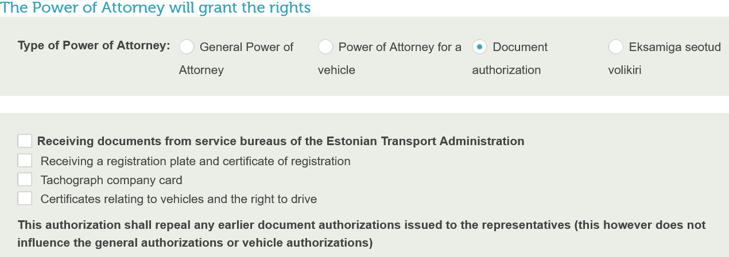

A natural person can grant the following rights

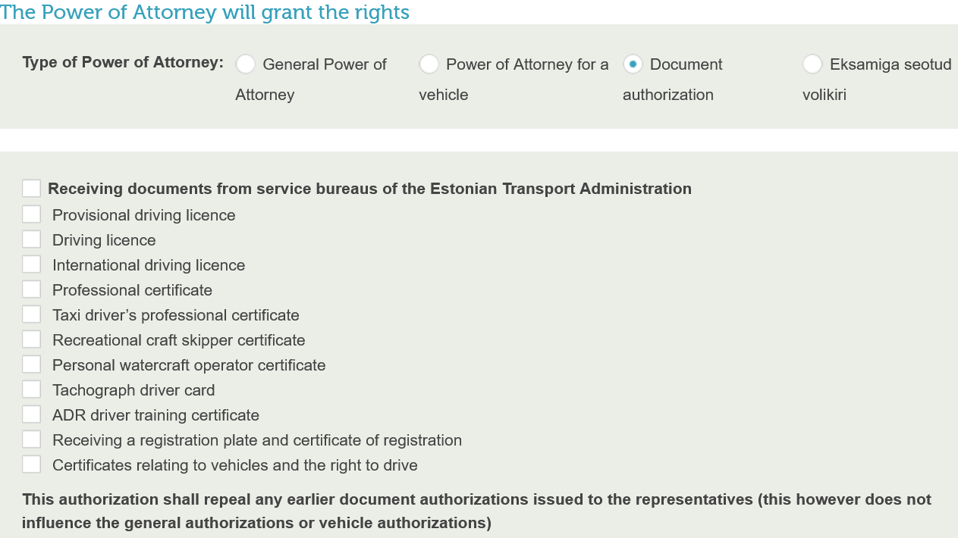

**STEP V: SIGNING**

Check the submitted data and sign the power of attorney using an ID-card, Mobile-ID or Smart-ID. After the power of attorney has been signed, it can also be downloaded as a digidoc file.

**STEP VI: CHANGING AND CANCELLING**

In the "Authorizations" view, You can also change or cancel the valid powers of attorney granted to others. In order to change the power of attorney You should first open it and then click "Change" or "Cancellation of power of attorney". When editing, You should proceed the same way as granting a power of attorney.