|  |  |
| --- | --- |
| **Name and duration of the programme** | Road Safety Programme  2016–2025 |
| **Performance area** | Transport |
| **General objective of the performance area** | The transport system in Estonia enables movement of people and goods in an accessible, convenient, fast, safe and sustainable manner. |
| **The objective of the programme** | Decreasing the number of road fatalities and serious injuries. |
| **Ministry responsible**  **(ministries sharing responsibility)** | The Ministry of Economic Affairs and Communications. Ministries sharing responsibility: The Ministry of Education and Research, the Ministry of Justice, the Ministry of Finance, the Ministry of Interior and the Ministry of Social Affairs. |
| **Brief summary of contents** | The death or injury of any people in road traffic is not acceptable. When making decisions concerning the road safety system, the goal on all decision levels is to ensure maximum road safety. The basis for this shall be a philosophical approach to road safety – Vision Zero. Vision Zero is not an objective of the Road Safety Programme, instead it is primarily a strategic framework in the road safety way of thinking and conclusions and activities resulting from it. In order to achieve the objectives of road safety, focus is placed on three main fields that affect road safety. The field “Responsible road user who is aware of dangers” focuses on shaping precautionary traffic behaviour and attitudes that value the safety of all road users. The field “Safe environment” encompasses safer and more efficient traffic that is socially acceptable, environmentally friendly and takes into account the characteristics of traffic during different seasons. The field “Safe vehicle” focuses on the use of safer vehicles in traffic. |
| **Governance arrangements** | The activities of the Road Safety Programme shall be covered by a implementation plan, the duration of which is four years. The implementation plan is in compliance with the state budget strategy and has a rolling cycle, i.e. another planned year shall be added to the implementation plan with each passing year. The implementation plan shall be coordinated with ministries that will contribute to the Road Safety Programme financially or with supporting activities and the implementation plan, along with the implementation plan of the transport development plan, will be confirmed by the Government of the Republic.  A traffic committee has been created at the Government of the Republic; the tasks of this committee include setting strategic goals and priorities of road safety and coordinating activities arising from the Road Safety Programme. The Ministry of Economic Affairs and Communications organises the implementation of the Road Safety Programme. The tasks of the Road Administration in implementing and directing the Road Safety Programme include general monitoring, harmonizing dissenting opinions and activities of different parties, organising reporting and updating of the Road Safety Programme. Other ministries and their divisions that take part in the implementation of the Road Safety Programme implement the Road Safety Programme on the basis of the compiled plan. A regional traffic committee coordinates the implementation of local and regional activities in counties.  Once a year, ministries and their divisions that take part in the implementation of the Road Safety Programme compile a performance report about the implementation of measures and activities in their area of responsibility and submit it to the Road Administration by 1 February of the following year, at the latest. The Road Administration will compile a report of the execution of the implementation plan based on the performance reports. This report shall be introduced at the traffic committee of the Government of the Republic prior to approval. |

Table of Contents 2

Introduction 4

1. Overview of the current situation 4

1.1. Preliminary assessment of the first „Estonian National Traffic Safety Programme“ 4

1.2. Statistical overview of the current situation 6

2. The objective and measures of the Road Safety Programme………………………..12

2.1. Increase in safety awareness and changes in the development of road safety 14

3. Road safety principles and management model of road safety activities 15

3.1. Vision Zero as an approach. Shared responsibility. 15

3.2. Systemic nature 16

3.3. Prevention, not reaction. 17

3.4. Knowledge-based activities 17

3.5. Management model of road safety activities 17

4. Responsible road user who is aware of dangers 18

4.1. Measure: pedestrian safety 19

4.2. Measure: cyclist safety 20

4.3. Measure: elderly road users 20

4.4. Measure: traffic education 21

4.5. Measure: driver training 21

4.6. Measure: prevention 21

4.7. Measure: driver’s health 22

4.8. Measure: traffic supervision 22

4.9. Measure: rehabilitation 23

5. Safe traffic environment 23

5.1. Measure: land-use and planning of the road network 24

[5.2. Measure: designing, building and reconstructing a sustainable   
and safe infrastructure 24](#_Toc498006648)

5.3. Measure: road maintenance 24

5.4. Measure: traffic management 24

5.5. Measure: level crossing safety 25

5.6. Measure: safe driving speed 25

5.7. Measure: intelligent transport systems (ITS) 25

6. Safe vehicle 26

6.1. Measure: support system for drivers 26

6.2. Measure: vehicle safety 26

6.3. Measure: safety of a work related vehicle 26

7. Summary 27

## Introduction

The Road Safety Programme is part of the “Transport” performance area of the state budget strategy and is compiled on the basis of the 3rd sub-objective “Decreasing traffic damages” of the “National Transport Development Plan 2014–2020” and section 5 of the “National road traffic safety Programme”. The Road Safety Programme (hereinafter the *Road Safety Programme*) is compiled for the years 2016–2025[1] and is a continuation of the first “Estonian National Traffic Safety Programme for 2003–2015”. The Road Safety Programme takes into account how the objectives set for the previous period were achieved, experiences gained and the experiences of other, more successful countries. Traffic environment, traffic behaviour and vehicles have changed a lot within 12 years. The road safety policy of the European Union (hereinafter the *EU*) has also been changed and tightened.

In the field of road safety, objectives of the European Commission are clear and ambitious – decrease the number of road fatalities to zero by 2050 and, in compliance with that objective, decrease the number of road fatalities half-way to that objective by 2020 (when compared to 2010). Estonia shares the European Commission’s views[2] in terms of long-term objectives and contributes to achieving those. Road safety encompasses a lot of different fields of life and involves very many different parties. The continuous increasing of road safety requires that all parties act in a continuous, systematic and coordinated manner during a lengthy period. Achieving the objective is possible only is the principles, general fundamentals and activities of road safety have been agreed upon unanimously and implemented successfully. The objective of the Road Safety Programme is to implement measures to continuously improve road safety more effectively and to reduce the number of persons killed or seriously injured in traffic accidents.

## Overview of the current situation

## Preliminary assessment of the first „**Estonian National Traffic Safety Programme“**

“Estonian National Traffic Safety Programme”[3] (hereinafter the *ENTSP*) laid down a total of 255 activities for the years 2003–2015; the activities were distributed into three implementation stages[4][5]. During 2003–2014, 37% of the ENTSP activities were implemented in full (i.e. as planned). 40% of the activities were implemented partially, at a smaller volume and/or later than initially planned. 23% of the ENTSP activities were not implemented, postponed or abandoned.

The initial general objective of the ENTSP was to ensure that the number of road fatalities in 2015 would be lower than 100. Authorities were rather optimistic when compiling the last stage of the implementation plan (there were 79 road fatalities in 2010) and the general objective was amended. The new amended strategic objective was to achieve a situation, by 2015, where the average number of road fatalities over three years would not exceed 75 people per year and the average number of people injured in traffic accidents during 2013–2015 would not exceed 1,500 per year. Additionally, specific target groups and spheres were determined; influencing those target groups and spheres could improve road safety significantly. These target groups and spheres were the following:

* cycle and pedestrian traffic;
* children and the elderly;
* passengers;
* less experienced and novice drivers;
* drunk driving;
* severity of road accidents;
* urban traffic;
* traffic during night-time;
* traffic in the winter.

During the validity period of the ENTSP, activities that were conducted the most were those aimed at road users: improving the efficiency of the traffic safety education and training system, increasing the traffic knowledge of road users, shaping safe traffic habits, behaviour norms and attitudes. When focusing on the ENTSP, making the traffic environment safer was rather random, unsystematic and based primarily on the needs and opportunities of other development plans (e.g. road management plan, transport development plan). 49% of activities aimed at road users were implemented in full, whereas 36% of activities meant to impact the safety of vehicles and only 17% of activities in the field of traffic environment were implemented.

The main shortcomings in implementing the ENTSP were the following:

1. Lack of comprehensive management system of road safety. Activities related to road safety were irregular, there was no clear organisation of road safety activities (e.g. in the form of regional road safety programmes) on the regional or local level.
2. As road safety is a multidisciplinary field, the implementation of the ENTSP required participation and interest from various parties. The activities of ENTSP were not priorities for the ministries responsible, therefore, the implementation of those activities was more formal. Limited financial resources certainly had a significant impact.
3. When planning ENTSP activities, the main driver was that the safety of a road user depends primarily on their own behaviour and habits. Therefore, most activities (63%) were aimed at road users. The safety of the transport system nor the increasing of responsibility of the people shaping the transport system was sufficiently included in the activities.
4. Even though public interest towards road safety and awareness of its importance grew significantly during the validity period of the ENTSP, the media coverage of the ENTSP, its objectives, activities and achievements was not sufficient.

A more thorough analysis of the implementation of the ENTSP, the effects of activities planned in it to traffic safety and the general effectiveness of the Traffic Safety programme will be included in the summary report compiled in 2016.

#### Statistical overview of the current situation

The first stage of the ENTSP during 2003–2007 brought along a 19% increase in the number of road fatalities. Significant changes implemented during the second stage of the ENTSP during 2008–2011 brought about a 48% decrease in road fatalities when compared to the same number at the end of the first stage. There have been no significant improvements in this situation during the third stage of ENTSP, which stated in 2012. Both the number of traffic accidents and fatalities and injuries from traffic accidents has remained without positive changes throughout the whole stage.

Even though the activities conducted in the framework of the Traffic Safety Programme should not be underestimated, a significant impact in the rapid decrease in traffic accidents during 2008–2010 resulted from the economic crisis, which brought about a decrease in traffic intensity and therefore impacted road safety positively. The level of road safety achieved in 2011 has been maintained, however, attempts to increase it further have been unsuccessful. When compared to 2010[6] (79 fatalities), the number of fatalities in traffic accidents decreased only by 1.3% (78 fatalities in 2014). The final objective of the Traffic Safety Programme was to reach a level, by 2015, where the average number of road fatalities over three years (2013–2015) would not exceed 75 people.

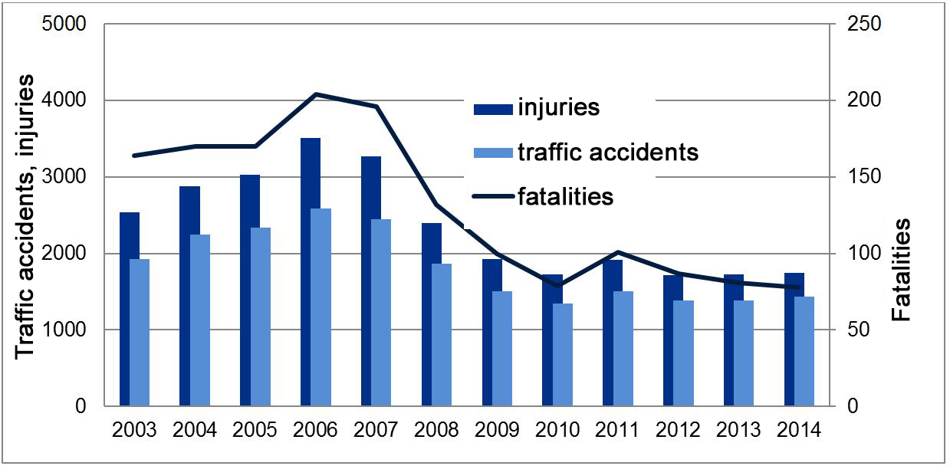

**Figure 1.** Traffic accidents, fatalities and injured people during 2003–2014

The number of fatalities among pedestrians in traffic accidents increased by 85% during 2010–2014. Starting from 2010, the number of deceased drivers of motor vehicles has decreased by 8% and the number of deceased passengers has decreased by 31%.

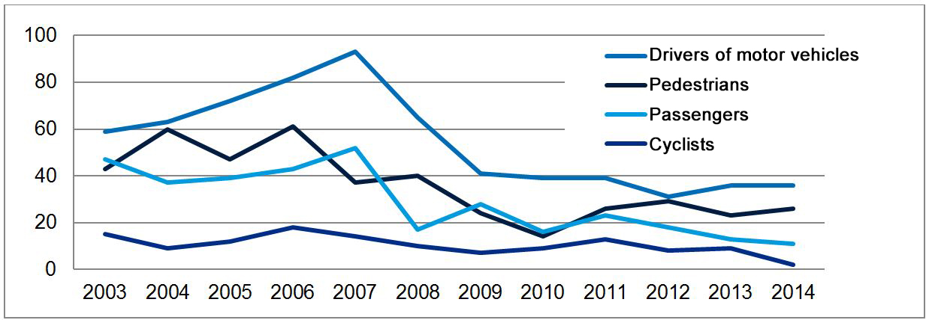

**Figure 2.** Road fatalities among drivers of motor vehicles, pedestrians, passengers and cyclists during 2003–2014

The number of car accidents involving pedestrians has not changed significantly when compared to 2010. The 378 accidents registered in 2014 exceed the number of those registered in 2010 by 5. The number of collisions involving multiple vehicles, excl. collisions with bikes, only decreased by 4, i.e. 1%, when compared to the number of collisions in 2010. However, traffic accidents involving pedestrians and head-on collisions on national roads continue to have the highest number of victims. In 2012–2014, a total of 57 people died as a result of head-on collisions on national roads, that makes up 32% of the 179 fatalities on national roads; 40 people died after being hit by a car, this makes up 22% of all fatalities on national roads.

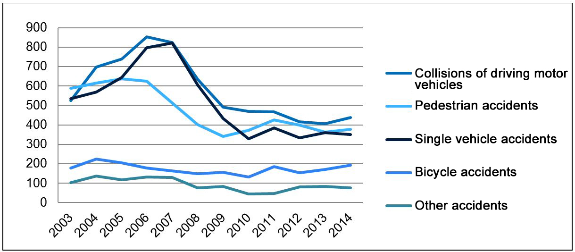

**Figure 3.** Types of traffic accidents during 2003–2014

Even though according to data from Statistics Estonia, the number of young people aged 15–24 has decreased by 19% when compared to 2010, the percentage of young people is still the highest among drivers involved in traffic accidents. The likelihood of getting in an accident increases when young people turn 18 and primarily drive passenger cars; this likelihood level remains continuously high for about ten years. About 160–200 motorcycle and moped traffic accidents involving victims are registered annually; those accidents involve 10–13 fatalities and up to 240 injured people. No significant changes have occurred as of 2010. In the past, most accidents where a car hit a cyclist occurred on rural roads, whereas in the past few years, this type of accidents have become more common in towns. Children and young cyclists continue to be at risk primarily in urban traffic.

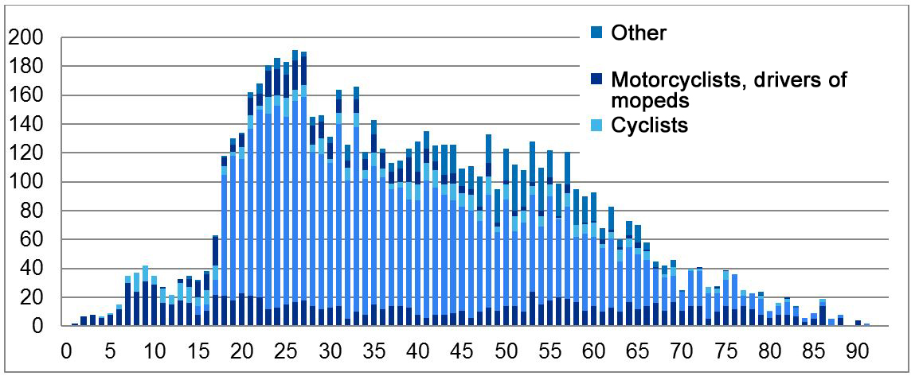

**Figure 4.** Age of drivers and pedestrians in traffic accidents during 2012–2014

Just as the risk of accidents is greatest among drivers aged between 16–24, the number of people killed or injured in traffic accidents per million inhabitants is also highest among the same age group of road users who drive passenger cars. The highest number of fatalities that occur among pedestrians or cyclists are fatalities of elderly people. The percentage of children is high among injured persons.

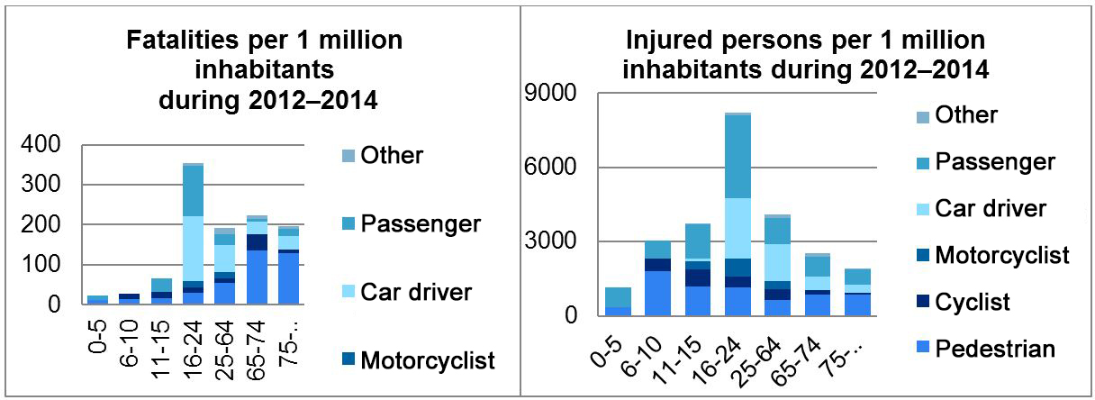

**Figure 5.** Distribution of road fatalities and people injured in traffic accidents by age (as an average for 2012–2014)

In 2012–2014, 39% of all registered traffic accidents that resulted in injuries to people occurred on national roads. National roads make up 28% of the Estonian road network. 55% of accidents occurred on rural streets of municipalities and 2% of accidents occurred on rural roads. 4% of accidents occurred on private roads or in places where the owner of the road was not determined.

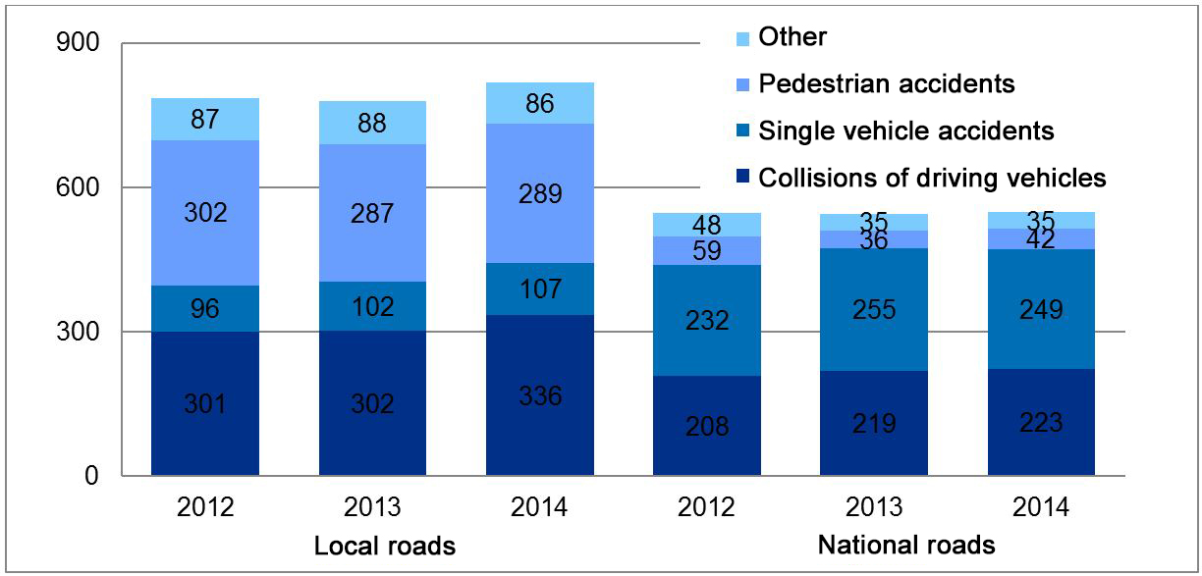

**Figure 6.** Traffic accidents on roads during 2012–2014

73% of fatalities occurred on national roads, 25% on streets of municipalities and 2% on local rural roads.

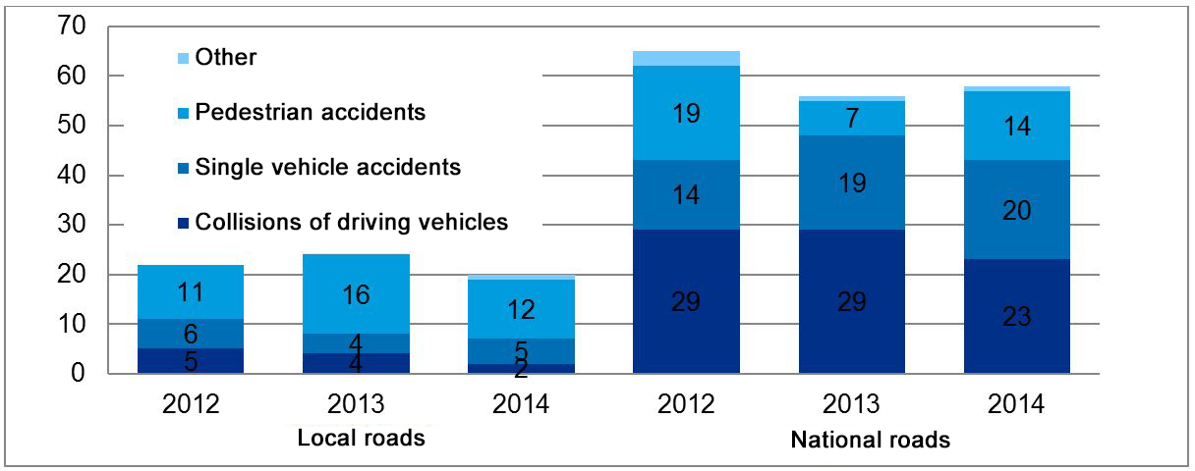

**Figure 7.** Number of traffic accident fatalities on roads during 2012–2014

The number of fatalities on the state’s major roads decreased by 34% in 2014. As of 2013, the number of fatalities increased on secondary roads, where most of the fatalities were caused by a motor vehicle driving off the road or collisions of motor vehicles.

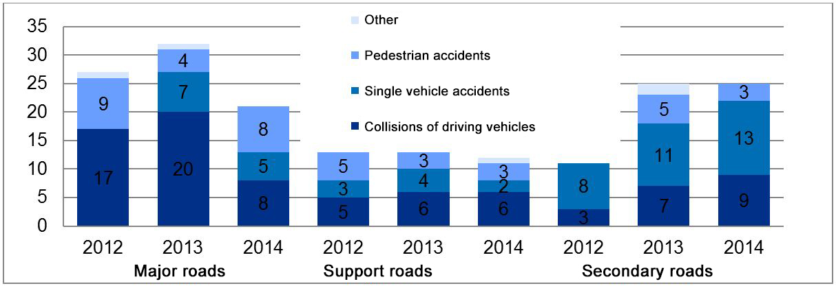

**Figure 8.** Fatalities on national roads during 2012–2014

On local roads, most accidents occur in urban traffic. Vulnerable road users make up a vast majority of fatalities in urban traffic.

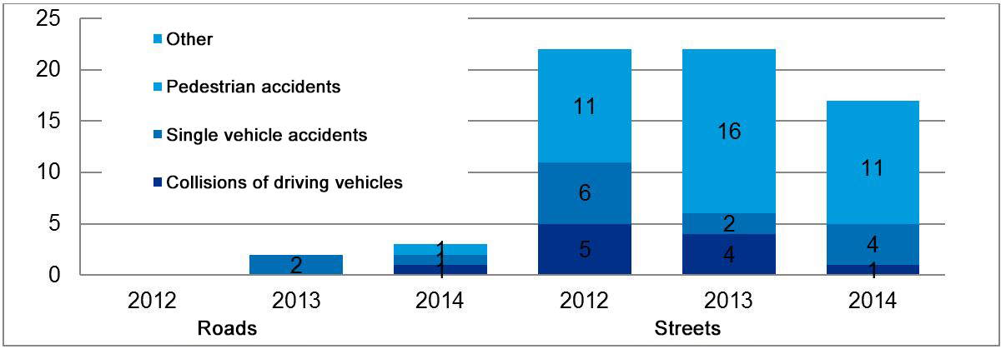

**Figure 9.** Fatalities on local roads during 2012–2014

In 2014, there were 818 traffic accidents, incl. 20 fatalities and 869 injured persons, on local roads. 84% (687) of those accidents occurred in Tallinn, Tartu, Pärnu and Narva; those accidents brought about 55% (11) of road fatalities and 87% (765) injury cases. 87% of people injured in accidents on local roads were injured in accidents that occurred in the four larger cities.

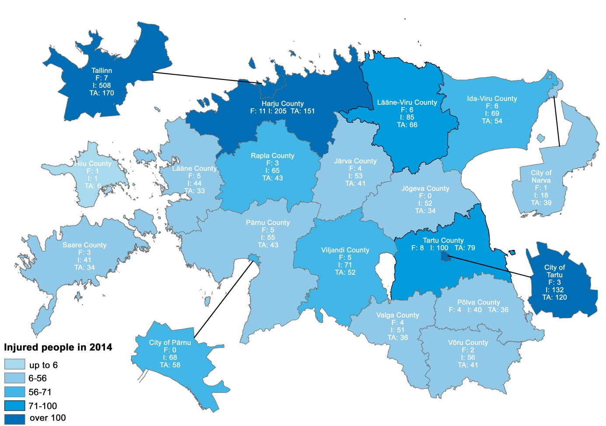

**Figure 10.** Traffic accidents with fatalities and injured persons in counties and big cities in 2014

In 2010, Estonia (59 fatalities per 1 million inhabitants) ranked better than the average for EU countries (63), but the road safety in Estonia has not improved in the following years (2011 – EST 76, EU 61; 2012 – EST 66, EU 56; 2013 – EST 61, EU 51; 2014 – EST 59, EU 51). In the last four years, road fatalities in the EU have decreased by 18.2%. The decrease in Estonia has been 1.3%.

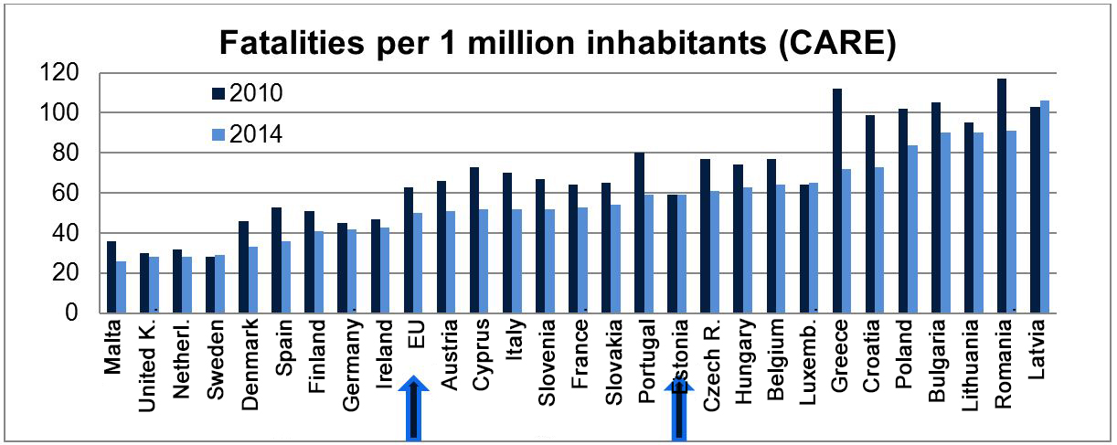

**Figure 11.** Road fatalities in the EU per 1 million inhabitants (when compared to 2010)

## The objective and measures of the Road Safety Programme

|  |  |  |  |  |
| --- | --- | --- | --- | --- |
| **Objective: decreasing the number of road fatalities and serious injuries** | | | | |
| **Measures** | **Starting level 2014 (average for 2012–2014)** | **Mid-level 2020 (average for 2018–2020)** | **Target level 2025 (average for 2023–2025)** | **Source** | |
| **Number of fatalities** | **82** | **50** | **40** | Road Administration | |
| **Number of seriously injured persons** | **475** | **370** | **330** | Ministry of Social Affairs | |
| **Total number of fatalities and injured persons** | **557** | **420** | **370** | Road Administration/  Ministry of Social Affairs | |
| Among those: | | | | | |
| Number of killed pedestrians | 26 | 15 | 11 | Road Administration | |
| Number of seriously injured pedestrians | 133 | 110 | 98 | Ministry of Social Affairs | |
| Number of killed cyclists | 6 | 3 | 3 | Road Administration | |
| Number of seriously injured cyclists | 42 | 35 | 30 | Ministry of Social Affairs | |
| Number of killed drivers of motor vehicles | 34 | 22 | 18 | Road Administration | |
| Number of seriously injured drivers of motor vehicles | 177 | 132 | 118 | Ministry of Social Affairs | |
| Number of killed passengers[7] | 14 | 10 | 7 | Road Administration | |
| Number of seriously injured passengers | 123 | 93 | 84 | Ministry of Social Affairs | |

In order to assess efficiency, objectives have been specified in categories for road users – target levels have been set for decreasing road fatalities and injuries among pedestrians, cyclists, drivers and passengers of motor vehicles.

**Table 1.** Decline in the average number of fatalities in traffic accidents over three years

|  |  |  |  |  |  |  |  |  |  |  |
| --- | --- | --- | --- | --- | --- | --- | --- | --- | --- | --- |
|  | Pedestrians | | Cyclists | | Drivers of motor vehicles | | Passengers | | Total | |
| Average over 3 years | Objective | Saved lives | Objective | Saved lives | Objective | Saved lives | Objective | Saved lives | Objective | Saved lives |
| 2013–2015 | 25 |  | 4 |  | 33 |  | 13 |  | 75 |  |
| 2014–2016 | 24 | 1 | 4 | 0 | 29 | 5 | 13 | 1 | 70 | 7 |
| 2015–2017 | 22 | 3 | 4 | 0 | 27 | 7 | 12 | 2 | 65 | 12 |
| 2016–2018 | 19 | 6 | 4 | 0 | 26 | 8 | 11 | 3 | 60 | 17 |
| 2017–2019 | 17 | 8 | 4 | 0 | 24 | 10 | 10 | 4 | 55 | 22 |
| 2018–2020 | 15 | 10 | 3 | 1 | 22 | 12 | 10 | 4 | 50 | 27 |
| 2019–2021 | 14 | 11 | 3 | 1 | 22 | 12 | 9 | 5 | 48 | 29 |
| 2020–2022 | 13 | 13 | 3 | 1 | 21 | 13 | 9 | 5 | 46 | 32 |
| 2021–2023 | 13 | 13 | 3 | 1 | 20 | 14 | 8 | 6 | 44 | 34 |
| 2022–2024 | 13 | 13 | 3 | 1 | 19 | 15 | 7 | 7 | 42 | 36 |
| 2023–2025 | 12 | 14 | 3 | 1 | 18 | 16 | 7 | 7 | 40 | 38 |
|  |  | 92 |  | 6 |  | 112 |  | 44 |  | 254 |

**Table 2.** Decline in the average number of persons seriously injured in traffic accidents over three years

|  |  |  |  |  |  |  |  |  |  |  |
| --- | --- | --- | --- | --- | --- | --- | --- | --- | --- | --- |
|  | Pedestrians | | Cyclists | | Drivers of motor vehicles | | Passengers | | Total | |
| Average over 3 years | Objective | Prevented damage to health | Objective | Prevented damage to health | Objective | Prevented damage to health | Objective | Prevented damage to health | Objective | Prevented damage to health |
| 2012–2014 | 133 |  | 42 |  | 177 |  | 123 |  | 475 |  |
| 2014–2016 | 128 | 5 | 41 | 1 | 168 | 9 | 117 | 6 | 454 | 21 |
| 2015–2017 | 124 | 9 | 39 | 3 | 159 | 18 | 111 | 12 | 433 | 42 |
| 2016–2018 | 119 | 14 | 38 | 4 | 150 | 27 | 105 | 18 | 412 | 63 |
| 2017–2019 | 115 | 18 | 36 | 6 | 141 | 36 | 99 | 24 | 391 | 84 |
| 2018–2020 | 110 | 23 | 35 | 7 | 132 | 45 | 93 | 30 | 370 | 105 |
| 2019–2021 | 108 | 25 | 34 | 8 | 129 | 48 | 91 | 32 | 363 | 112 |
| 2020–2022 | 106 | 27 | 33 | 9 | 126 | 51 | 90 | 33 | 355 | 120 |
| 2021–2023 | 104 | 29 | 32 | 10 | 124 | 53 | 88 | 35 | 348 | 127 |
| 2022–2024 | 102 | 31 | 31 | 11 | 121 | 56 | 87 | 36 | 340 | 135 |
| 2023–2025 | 100 | 33 | 30 | 12 | 118 | 59 | 85 | 38 | 333 | 142 |
| Total |  | 214 |  | 71 |  | 402 |  | 264 |  | 951 |

In order to reach the target levels, focus will be placed on three main fields that affect road safety: responsible road user who is aware of risks, safe environment and safe vehicle. The Road Safety Programme includes plans for measures that are necessary for achieving the objectives on road safety. Activities that are necessary for implementing these measures shall be specified in the implementation plan of the road safety programme. The first implementation plan is compiled for 2016–2019.

#### 2.1. Increase in safety awareness and changes in the development of road safety

The increase in road users’ safety related awareness and changes in the development of road safety can be assessed. The current state and achievement levels characterise the expected changes in road users’ behaviour, traffic environment and technical condition of vehicles.

**Table 3.** The current state and estimated changes in road users’ behaviour, traffic environment and technical condition of vehicles

|  |  |  |  |
| --- | --- | --- | --- |
| Evaluated sphere | Indicator | Starting level **2014** | Target level **2025** |
| Road user | Use of mobile phone while driving | 70% S[8] | 50% |
| Road user | Failure of a driver of a motor vehicle to comply with the red traffic light | 42% O[9] | 32% |
| Road user | Failure of pedestrian to comply with the red traffic light | 11% O | 8% |
| Road user | Giving way to a pedestrian on an unsignalised pedestrian crossing | 74% O | 90% |
| Road user | Use of safety belt in a car – driver | 95% S | Does not decrease |
| Road user | Use of safety belt in a car – passenger in the front seat | 97% S | Does not decrease |
| Road user | Use of safety belt in a car – passenger in the back seat | 81% S | 90% |
| Road user | Use of safety belt in a car – children | 95% S | Does not decrease |
| Road user | Use of safety belt in a bus – passengers in seats equipped with safety belts | 23% S | 60% |
| Road user | Using a bike helmet under the age of 16 | 69% S | 80% |
| Road user | Using a bike helmet among adults | 22% S | 40% |
| Road user | Use of pedestrian reflector – children | 93% S | 95% |
| Road user | Use of pedestrian reflector – adults | 66% S | 70% |
| Road user | Exceeding the speed limit in a settlement | 72% S | 35% |
| Road user | Exceeding the speed limit (by more than 10 km/h) on a main road | 45% S | 30% |
| Road user | Exceeding the speed limit (by more than 10 km/h) on smaller roads | 37% S | 30% |
| Road user | Percentage of drunk drivers among those tested during a[10] statistical police operation “Everyone blows” (into breathalyzers, that is)[11] | 0.15% | 0.11% |
| Road user | Drunk driving according to road users | 13% S | 7% |
| Road user | Percentage of people who pass the practical driving test on their first attempt | 58.5% | 68% |
| Environment | Installation of an additional centre barrier on a national road (km) | 0 | 82 |
| Environment | Installation of an additional roadside barrier on a national road (km) | 0 | 80 |
| Environment | Kilometres of additional central line rumble strip on a national road | 0 | 1,500 |
| Environment | Additional kilometres of walkways and cycle tracks on local roads | 0 | 60 |
| Vehicle | Percentage of vehicles in traffic that are more than 10 years old | 52.8% | 50% |
| Vehicle | Percentage of M1 category vehicles (passenger cars) that passed the roadworthiness test on the first attempt | 89.9% | 85%[12] |
| Vehicle | Percentage of M3 category vehicles (buses) that pass the roadworthiness test on the first attempt | 87.8% | 85%12 |
| Vehicle | Percentage of N2 category vehicles (trucks, 3.5–12 tonnes) that passed the roadworthiness test on the first attempt | 89.3% | 85%12 |
| Vehicle | Percentage of N3 category vehicles (trucks that weigh more than 12 tonnes) that passed the roadworthiness test on the first attempt | 90% | 85%12 |

## Road safety principles and management model of road safety activities

#### Vision Zero as an approach. Shared responsibility.

In the field of road safety, Vision Zero was first used in 1997, [13]in Sweden. Since then, this road safety approach has been implemented in most European countries (e.g. in the United Kingdom as the Safe Systems Approach, Sustainable Safety in the Netherlands, Vision Zero Approach in Norway). OECD has also recommended that member states base their activities on the principles of Vision Zero[14]. Vision Zero is based on four principles:

* Ethics: a person’s life and health are most important. These are more important than mobility or other functional goals of a road traffic system.
* Chain of responsibility: the planners, implementers and managers are responsible for the safety of the system. Road users are responsible for following traffic rules.
* Safety philosophy: people make mistakes. The transport system should minimize opportunities for road users to make mistakes and the potential damages of mistakes as much as possible.
* Changes are driven by mechanisms: the planners, implementers and managers of the transport system have to create prerequisites for safe movement in traffic. All parties must be ready for changes necessary for creating these prerequisites.

Vision Zero differs from traditional approach in the following aspects:

**Table 4.** Differences between Vision Zero and the traditional approach

|  |  |  |
| --- | --- | --- |
|  | **Traditional approach** | **Vision Zero approach** |
| Objective | Reduce the number of traffic accidents | Reduce the number of road fatalities and serious injuries |
| Safety of road users | Depends on their behaviour | Depends on the safety of the system developed |
| Safety is the responsibility of | Road user | Authority who planned the system |
| Changes | Behaviour of road user | Primarily environment (traffic environment, vehicle, support through social behaviour norms), which brings about changes in behaviour |
| Safety | People do not care about it | Fundamental human need |

The transport system is one of the most complex and dangerous systems created by people. Road safety starts with planning use of space and land. Traffic accidents and even minor injuries are inevitable in the traffic system, however, the chain of events leading to fatalities of permanent damage to health can be disrupted. The road traffic system should be changed into one where road users would make as few mistakes as possible and the damages caused by these mistakes would be as small as possible. When planning the system, potential mistakes should be taken into account to ensure that lives are not lost or serious health damage caused even if a road user makes a mistake or fails to follow certain rules. All parties, both road users and people shaping the system, are responsible for road safety. Changes are necessary for shaping the system to be safe. Therefore, all parties have to be open to change. Ensuring road safety as a social issue should not be dependent on anyone’s political or business interests.

#### Systemic nature

Success can only be achieved through implementation on various complex measures, in which there are clear connections between individual activities. The higher the level on road safety already achieved, the less success can be achieved through individual activities. The role and cooperation necessity of activities increases. By now, most effective road safety activities have already been implemented in Estonia at least partially. The previously used model, in which individual activities are sought out and implemented, is no longer functional. It is important to improve the efficiency of individual activities, but it is more important to improve the way activities function together. The key to road safety during the following period lies primarily in improving the functionality of measures that have been implemented poorly so far. When planning road safety activities, the basis should be taken primarily from factors that cause and facilitate traffic accidents, while keeping in mind indirect risk factors. All circumstances related to individual traffic accidents are taken into account when shaping the complete system, however, a single case that was in the centre of heightened public interest cannot be the basis for amending the priorities of road safety activities.

#### Prevention, not reaction.

When shaping the road safety system, it has been custom to focus on determining risks that led to a traffic accident and on mitigating those risks. Relying on this approach alone is no longer enough as:

* Reacting to consequences is, by its nature, contradictory to the principles of Vision Zero;
* Prevention of problems already in the traffic system planning stage is considerably more cost-effective due to its smaller expenses and more significant impact;
* The non-occurrence of a traffic accident does not mean that the risks have been mitigated sufficiently[15].

A traffic system can be safe only if all of its components are planned and implemented in the safest way possible. In order to prevent traffic accidents, it is necessary to ensure that all activities related to road safety, incl. traffic solutions (road‑ construction, maintenance, traffic management) created on state roads, local and private roads would be in compliance with the best road safety practices determined at that time.

#### Knowledge-based activities

Traffic is a complicated system in which changing one parameter can launch a series events, the result of which can be unforeseeable in the case of insufficient experience. Causal relationships in traffic are often multidirectional and complex. People, incl. traffic experts, cannot always comprehend traffic risks objectively. The effects of a lot of road safety related activities cannot be predicted based on regular logic and the scope of their impact can change with time. This creates a situation where activities implemented with the best of intentions may not increase safety as expected. In the worst case scenario, those activities can increase traffic risks instead. Changes in the traffic system can be implemented only if their negative impact has been ruled out on the basis of the best modern knowledge on road safety. Primary focus should be placed on implementing those road safety measures and activities, the effectiveness of which has been proved scientifically or through long-term experience. Determining changes in the current state of traffic safety, predicting the influence of planned activities and assessing the influence of implemented activities is possible only if there is sufficiently detailed data accessible concerning traffic accidents and risks, and relevant authorities and research institutes have the necessary analysis capabilities.

#### Management model of road safety activities

A management model of road safety activities, which is uniform, functional and enables cooperation, shall be created on a national, regional and local level, involving as many parties as possible in solving road safety related issues. The performance and effectiveness of the implementation plan shall be assessed annually. When making decisions concerning the transport system, the goal on all decision levels is to ensure maximum road safety. The activities of the Road Safety Programme shall be covered by an implementation plan, the duration of which is four years. The implementation plan is in compliance with the state budget strategy and has a rolling cycle, i.e. another planned year shall be added to the implementation plan with each passing year. The implementation plan shall be coordinated with ministries that will contribute to the Road Safety Programme financially or with supporting activities and the implementation plan, along with the implementation plan of the transport development plan, will be submitted to the Government of the Republic for approval.

A traffic committee has been created at the Government of the Republic; the tasks of this committee include setting strategic goals and priorities of road safety, coordinating activities arising from the Road Safety Programme and providing consultation and submitting proposals with regard to solving road safety issues to the Government of the Republic. The Ministry of Economic Affairs and Communications is the main ministry responsible for the implementation of the Road Safety Programme. The Ministry of Education and Research, the Ministry of Justice, the Ministry of Finance, the Ministry of Interior and the Ministry of Social Affairs and divisions of ministries that are involved in the implementation of the Road Safety Programme are also responsible for the implementation of the Road Safety Programme. Municipalities are also involved in the implementation of the Road Safety Programme. The tasks of the Road Administration in implementing and directing the Road Safety Programme include management of the work of the traffic committee, general monitoring of the Road Safety Programme, harmonizing dissenting opinions and activities of different parties, organising reporting and updating of the Road Safety Programme. The other ministries and their divisions that take part in the implementation of the Road Safety Programme do so according to the plan.

In order to get an overview of the achievement of the objectives of the Road Safety Programme, the performance of the implementation plan is assessed annually. Once a year, ministries and their divisions that take part in the implementation of the Road Safety Programme compile a performance report about the implementation of measures and activities in their area of responsibility and submit it to the Road Administration by 1 February of the following year, at the latest. The Road Administration will compile a report of the execution of the implementation plan based on the performance reports. This report shall be introduced at the traffic committee of the Government of the Republic prior to submitting it for confirmation. The implementation plan of the Road Safety Programme is reviewed and, if necessary, updated once a year during the process of compiling the state budget. Proposals for additions to the implementation plan are submitted to the Government of the Republic along with the report on the implementation plan of the transport development plan. In order to compile the final report on the performance of the Road Safety Programme, ministries shall submit, to the Road Administration, a summary of the implementation of measures and activities in their field of responsibility during the entire period of the Road Safety Programme. The final report on the implementation of the Road Safety Programme is coordinated with the relevant ministries and the Government Office, discussed at the traffic committee of the Government of the Republic and submitted to the Government for approval.

## Responsible road user who is aware of dangers

Responsible behaviour that takes other road users into account is the key factor in everyone's contribution to overall road safety. The objective here is to shape precautionary traffic behaviour and attitudes that value the safety of all road users. Particularly important is the implementation of the principle of shared responsibility – the obligation to ensure your own safety and responsible attitude towards the safety of other road users. The measures focus on two different aspects – one related to the mindset and perceptions of the road user and the other to the traffic environment. Work will be continued on road safety training and awareness-raising to shape precautionary traffic behaviour and attitudes that value road safety. Through road safety training and awareness-raising, activities are directed primarily at high-risk road users (drunk, with a medical condition, without a right to drive, and risk seeking drivers) so that they would be able to cope with traffic, driver’s health condition and changes in the traffic environment caused by an aging population. Comprehensive systems are developed in order to improve the traffic behaviour of road users.

#### 4.1. Measure: pedestrian safety

|  |
| --- |
| **Objective of the measure**: the number of road fatalities and serious injuries among pedestrians has decreased. |

Pedestrians include people with very different levels of mobility, knowledge and skills, incl. disabled road users, children and the elderly. The safety of pedestrians is influenced by factors closely related to each other: road parameters and road user behaviour; night-time and pedestrian visibility; wintertime conditions and road maintenance; driving speed and severity of consequences. The measures proposed to reduce the number of accidents involving pedestrians are based on the aforementioned risks and the specifics of the traffic environment of a rural road, a road passing through a small settlement and the urban road and street network. For the purpose of shaping the attitudes and behaviours of a road user, activities related to the training, awareness-raising and traffic supervision, aimed at pedestrians and drivers are continuously developed. Road space must be planned and built to a greater extent than it is today, so as to prevent and limit road user mistakes and reduce the severity of the consequences of traffic accidents.

When designing road space, values influenced by the living environment should be taken into account more than previously to ensure accessibility and to create safe and convenient opportunities for travelling by foot. The streets must be designed to be suitable for different users; this may require the use of traffic calming measures. Equally important is the planning, construction or reconstruction of public transport stops, walkways and footpaths, in a way that increases pedestrian safety. Stricter safety requirements must be applied when organizing work on a repair object, thereby ensuring a traffic solution that prevents pedestrian and vehicle contact; the same applies to a situation where traffic management, which has become habitual for road users, is changed. Pedestrian and motor vehicle conflict prevention solutions need to be included in new plans more than ever before. In the traffic environment of rural roads, it is necessary to create conditions that are necessary for safety at places with a high concentration of pedestrian safety. In wintertime, road maintenance must provide the pedestrian with a safe and suitable road space for use. Failure to clear the snow from footpaths and roadsides can force pedestrians to walk on the carriageway.

During night-time, the likelihood of an accident is linked to the distance of noticing a pedestrian. The proper use of the pedestrian reflector in the dark significantly increases the visibility of the pedestrian on rural roads. The pedestrian reflector must be visible and in the noticeable for an approaching driver at the distance required for stopping. To ensure road safety in a settlement, one should not rely on their pedestrian reflector alone; the pedestrian must not forget their obligation to ensure safety. In the case of a traffic accident, the severity of the pedestrian’s injuries is in direct correlation with the velocity of collision. Focusing on a safe driving speed is an important basis when designing road space. Compliance with the speed limit is, in turn, influenced by road users’ mutually considerate behaviour, law-abiding behaviour, functionality of traffic supervision and the perception, concerning road parameters, gained directly from the traffic environment, which the driver takes into account when choosing their driving speed.

#### 4.2. Measure: cyclist safety

|  |
| --- |
| **Objective of the measure**: the number of road fatalities and serious injuries among cyclists has decreased. |

The percentage of cycle traffic (approximately 5% of all traffic) has grown year by year, but remains rather modest compared to countries with developed cycle traffic. The safety of the cyclist is closely linked to a well-designed bicycle infrastructure and daily bicycle use. A safer environment supports the increase in the percentage of bicycle users. The willingness of other road users to take cyclists into account and the uncompromising compliance to traffic rules by cyclists helps to significantly improve safety. A cyclist needs to be aware that they have a responsibility to ensure their own safety and to behave responsibly towards other road users.

At the moment, many objectives concerning improving cycle traffic are limited to the number of kilometers of cycle tracks to be created. However, less attention is paid to whether and how the proposed activities shall affect bicycle use and safety. One important part of the strategic planning tier of cycle infrastructure is the development of a unified network. A cyclist must be able to move from their point of departure to as many destinations as possible. However, connection with destinations is not the only requirement. It is also important to ensure quality of cycle lanes and necessary additional services. The creation of a cycle track network requires monitoring of its safety, directness, coherence, attractiveness and convenience. Situations where cycle safety and the need to use bicycles are ignored when updating infrastructure should be avoided.

The use of bicycle and cyclist safety equipment ensures both active safety, which prevents accidents, and passive safety, which mitigates the severity of consequences. As a cyclist is not required to wear safety clothing and an adult cyclist is not required to wear a helmet, increase in the use of those items is achieved mainly through traffic education (awareness-raising, training, etc.). The use of a bicycle helmets makes it possible to reduce the amount of head injuries in traffic accidents and when cyclists fall. Using safety equipment to improve the visibility of a cyclist (lights, reflectors, safety vest or clothing) reduces the likelihood of a traffic accident.

#### Measure: elderly road users

|  |
| --- |
| **Objective of the measure**: the number of road fatalities and serious injuries among the elderly has decreased, as has the number of traffic accidents caused by the elderly. |

Demographic projections show that the population of Estonia is aging. The characteristics of elderly people have to be taken into account when improving their knowledge and skills. The society has to adapt to requirements set for the traffic environment due to the aging population. The problems posed by the population aging can be divided into three groups: the safety of an elderly road user, matters related to the health requirements of an elderly driver and the creation of a refresher training system for elderly drivers of motor vehicles. By 2025, there will be at least another 85,000 elderly (aged 65+) drivers in Estonia, when compared to the current number. When compared to the current situation, the number of elderly female drivers will increase three-fold, the number of elderly male drivers will double. In order to ensure social activity and high quality of life among the elderly, their car use should be encouraged to use their cars and participate in training events. An elderly person who wishes to drive until old age should be aware and able to deal with age-induced reduced driving ability.

#### 4.4. Measure: traffic education

|  |
| --- |
| **Objective of the measure**: knowledge about road safety among road users has improved. |

It is vital to create conditions that support the development of correct attitudes and behaviours throughout the road user’s entire life in a multitude of ways. Important keywords are: movement as a person's daily fundamental human need; joint responsibility for being a role model for a young road user; valuing caring and consideration of others in traffic; knowledge and skills for safe driving; lifelong learning. It is necessary to make the activities systematic and continuous, as well as to expand them to all age groups. Fields of responsibility are divided as follows: higher education institutions – teachers’ further education and refresher training; education establishments – high-quality and systematic traffic education from kindergarten to driving school; local authorities – ensuring infrastructure and support functions; state agencies – activities for ensuring safety in traffic environment and for developing a uniform approach; family/community – responsibility for being personal role models and for developed behaviour norms; the third /private sector – communicate values in their activities, care for employees, social responsibility. Even though correct traffic habits should be shaped in early age, the shortcomings in basic school are the quality of teaching and implementation of teaching, which would enable achieve the objectives set in the national curriculum and to ensure the development of relevant competency.

#### Measure: driver training

|  |
| --- |
| **Objective of the measure**: the driver’s preparedness for safe traffic has improved. |

Driver training is the logical continuation of traffic related primary and basic education and an important tool for increasing awareness for safe traffic participation when driving a bike or a motor vehicle. In addition to being knowledgeable of traffic rules and being able to control a vehicle, it is also important that a future driver learns to assess risks, factors that increase risks in traffic and the limits of their own skills and abilities. In motor vehicle driver training, incl. moped and motorcycle training, it is important that the study period is intensive and that the student could get as much driving practice as possible prior to applying for the right to drive. The choices include the following: fully liberal (free) training system, i.e. the person who will learn driving can choose professional training (at a driving school), or non-professional training (driving with an instructor), or combined training, in which the person attends driving school and drives with their own instructor. The greatest challenge, regardless of the training system that the future driver has chosen, is to increase their awareness when shaping a responsible and safe driver who, in addition to technical skills, also possesses safe attitudes and who values their own safety and that of other road users. Most in need of attention here are surveillance of training establishments and checking the quality of examiners. Vocational training is to implement modular learning.

#### Measure: prevention

|  |
| --- |
| **Objective of the measure**: shaping safe traffic habits, behaviour norms and attitudes. |

The objective here is to minimise conscious risk-taking and to facilitate the shaping of road users who keep themselves safe and take others into consideration as well. This includes various activities (awareness-raising, training, networking, consultation, development), which supplement one another and compile a comprehensive unit for all road users. The activities are aimed at ensuring road safety for risk groups (incl. the elderly, disabled people and children), problematic subjects of road safety, legislative amendments concerning road safety and aspects impacted by demographic composition. Awareness-raising activities include awareness-raising campaigns, constant coverage of road safety topics and focus on related challenges. It is important to inform road users of various hazardous situations that may occur if they do not adhere to principles of safe traffic participation. Networking helps facilitate supporting healthy and safe traffic participation, continuous inter-agency activities and continuous activities of committees/commissions on the regional level, as well as involvement of civic associations. Road Administration as a competence centre of the traffic field organises road safety related consultation for municipalities and education establishments based on local needs.

Due to a lack of a shared communication space, a significant part of non-Estonian population is not in scope of road safety messages. In order to achieve set objectives, more activities that support the strengthening of a shared communication space are needed; these activities should take into account regional differences and direct more attention towards those regions in the Ida-Viru County and the Harju County where the population includes a lot of people who use Russian as their main language. Also needed are activities in English and Russian language print, television, radio and interactive media (e.g. article series, television and radio shows, developing and translating websites) to cover the topic of road safety. An integrated approach is needed for rad safety activities aimed at new immigrants.

#### Measure: driver’s health

|  |
| --- |
| **Objective of the measure**: the number of persons with reduced driving ability participating in traffic has decreased. |

The right to drive a vehicle is not something granted for everyone, instead, it requires that the person’s health status, incl. their mental health status, are suitable for driving. The medical examination conducted on the basis of the Traffic Act is aimed at acknowledging a driver’s traffic risks, checking that their health status complies to health requirements and identifying any health conditions that can be a traffic hazard. Integrating medical examinations with e-health enables the assessment of a driver’s health status in a more thorough way than the previous visit-based system did. Integrated systems ensure that a doctor is aware of a patient’s right to drive status when diagnosing them with a health condition that can be a traffic hazard; integrated systems also enable to initiate the suspension of the person’s right to drive and to make relevant information accessible for the issuer of the right to drive. It is necessary to create opportunities for assessing the driving ability of a driver of a motor vehicle and for counselling concerning preserving and improving driving ability, so that only drivers with sufficient driving abilities would participate in traffic.

#### Measure: traffic supervision

|  |
| --- |
| **Objective of the measure**: ensuring compliance to traffic rules. |

Traffic supervision is the most important and effective way of ensuring compliance to traffic rules; it also helps to improve road safety significantly. Research shows that full compliance to traffic rules could reduce traffic accidents by 50%. When planning activities, very clear danger criteria, environment details and road user behaviour are taken into account. Traffic supervision will be more method-based than it has previously been. The prerequisite for method-based surveillance is that all the information is accessible and the impact of its results can be assessed. Efforts are made to ensure that the effectiveness of traffic supervision and resulting sanctions would not be based solely on measuring the full compliance to rules, but would be more flexible and provide a better perception to the road user and allow them to take into account the real hazardous situation. Both physical and technical tools are installed at places that affect road safety (based on risk evaluations). In order to ensure that traffic supervision has maximum impact on road safety, it is necessary to focus human resources on traffic violations that have a direct and proven connection to road safety and the severity level of traffic accidents. Primary attention will be directed towards decreasing the number of risky traffic behaviour, the safety of non-motorized road users, eliminating drunk drivers from the traffic, checking that drivers adhere to the speed regime, checking safety equipment and adherence to requirements of driving, work and rest time, as well as transport requirements. The goal here is to simplify the conducting of misdemeanour procedures, but not on account of shortcomings in ensuring a person’s rights. A misdemeanour procedure will be conducted only if it is unavoidable. Automatic options of traffic surveillance shall be implemented more than previously.

#### Measure: rehabilitation

|  |
| --- |
| **Objective of the measure:** shaping law-abiding traffic behaviour of motor vehicle drivers through the process of counselling in order to restore traffic behaviour that is safe and takes into account other road users. |

Rehabilitation measures are post-violation activities meant for restoring driver eligibility. When selecting sanctions, the main emphasis should be placed on changing the behaviour of a person and this can be done best through the use of specific programmes. If necessary, an addiction treatment or a high-risk driver programme should be used. However, it is not necessary or proportional to adapt such programmes to all persons who have multiple violations – the obligation to be assigned must be risk-based and need-based. The benefits arising from the measure can reach further than road safety. This way, follow-up training courses meant for drunk drivers can result in a reduced number of alcohol-related illnesses and improve the life quality of people affected by it. The implementation of rehabilitation measures is started with drivers who have committed alcohol-related violations, then expanding, as needed, the measures to drivers who have conducted repeated traffic violations. As a lighter approach, intervention activities are planned in which the person is not sent to follow-up training or a treatment programme, but is instead involved in a counselling process, where they are directed to better acknowledge their problems.

## Safe traffic environment

Traffic environment encompasses land-use and planning of a safer road network, building new roads and reconstructing current roads, ensuring mobility, traffic management and road maintenance. The objective is a safer and more efficient traffic that is socially acceptable, environmentally friendly and takes into account the characteristics of traffic during different seasons. The measures are aimed at developing and managing traffic environment in a way that ensures that the traffic environment is easily comprehensible, road users could be aware of dangers in it, the number of potential mistakes would be reduced and that consequences of mistakes would be less severe. Vulnerable road users become more central. The biggest challenges are shaping a safe urban traffic environment, incl. improving the opportunities for walking, riding a bicycle and using public transport, and developing solutions for preventing traffic accidents with public transport vehicles and to enable safe overtaking opportunities on roads. In order to increase safety, traffic management must be based on the hazards of the traffic environment, in particular to ensure consistency between the traffic environment and the speed regime. People shaping the traffic environment need to perceive their responsibilities, since any changes in mobility (e.g. promoting and facilitating cycle and pedestrian traffic) without simultaneously implementing effective road safety measures can lead to irreparable damage.

#### Measure: land-use and planning of the road network

|  |
| --- |
| **Objective of the measure**: well thought-through land-use and planning of a safe road network. |

The measure provides for the implementation of activities that increase road safety already in the planning phase, for example, in road safety impact assessment plans. The planning needs to take into account, in particular, the requirement for optimization of mobility needs: compact land-use, reduction of compulsory traffic volume and movement distances help to prevent potential traffic conflicts.

#### Measure: designing, building and reconstructing a sustainable and safe infrastructure

|  |
| --- |
| **Objective of the measure**: designing, building and reconstruction of safe roads. |

The measure encompasses planning and constructing roads, specifically for improving road safety. Requirements set for planning roads have to be in compliance with the concept of the modern safe system, incl. Vision Zero and principles of sustainable safety. A thorough approach to safety during the early stages of planning and design (e.g. when auditing the road safety of a project), decreases the likelihood of that remedial measures, which are often artificial, are needed later on. The measure provides for identifying and eliminating dangerous places on national roads and in larger municipalities. Activities that should be highlighted here include determining activities for the physical separation of driving directions and various modes of transport, as well as for improving safety concerning driving off the road. More attention will be directed at implementing comprehensive solutions for calming traffic and for increasing the safety of vulnerable road users in the urban environment. Activities are continued for determining areas that are dangerous due to wild animals, to assess the effectiveness of implemented safety solutions and to improve road safety in relation to wildlife when planning new roads.

#### Measure: road maintenance

|  |
| --- |
| **Objective of the measure**: condition requirements of roads are met and up-to-date. |

The compliance of roads to condition requirements is ensured through road maintenance, which encompasses all road components resulting from the Building Code, incl. walkways and cycle tracks, as well as constructions used for participating in traffic. Condition requirements are updated based on their impact to road safety. Winter-time condition requirements must ensure road safety for pedestrians and cyclists, in addition to road users who use motor vehicles. A priority activity here is to develop and implement a model for measuring and forecasting road conditions. Efficient and continuous control that the condition of roads complies with condition requirements is ensured. Activities aimed at ensuring road safety should be given more importance than activities aimed at precise adherence to rules.

#### Measure: traffic management

|  |
| --- |
| **Objective of the measure**: ensuring sustainable and safe traffic management. |

Traffic management has to be simple and comprehensible, fit the environment, reduce traffic stress and help prevent mistakes in traffic participation. This measure makes the planning, implementation and surveillance of traffic management more efficient. Developed solutions shall ensure clear and unambiguous traffic management, incl. on construction sites. In order to make traffic participation safer, more smooth, and environmentally sustainable, options of intelligent transport systems (ITS) will be used more and more in traffic management.

#### Measure: at-grade railway crossing safety

|  |
| --- |
| **Objective of the measure**: the number of traffic accidents on at-grade railway crossings has decreased. |

Increasing train speed and increasing train traffic in the existing infrastructure will lead to an assessment of existing measures and the need for implementing additional safety measures, in particular on railway intersections (pedestrian crossings and level crossings). It is necessary to assess the adequacy of the safety measures applied on intersections that are at grade between a road and a railway, the circumstances of accidents that have occurred and the impact of the measures on the planned changes in the traffic environment. A railway intersection safety plan will be drawn up and additional activities will be implemented to ensure safety.

#### Measure: safe driving speed

|  |
| --- |
| **Objective of the measure**: establishing a safe driving speed. |

Exceeding the speed limit of safe driving impacts the number of fatalities and injuries the most. It influences both participation in traffic accidents and the consequences of traffic accidents. Higher impact speed results in higher impact energy and potential to cause injuries to people. When taking into account the concept of safe speed, the driver-vehicle-traffic environment system must operate in such a way that a road user would not be killed or suffer serious injuries. In many EU member states, the actual applied maximum speed limit has been sought to be linked to the speed that was taken into account when planning road geometry and to the speed that is in line with safety and actual road and traffic conditions. In Estonia, the principles for speed limits should be set based on the function of the road, traffic composition, frequency and land use.

#### Measure: intelligent transport systems (ITS)

|  |
| --- |
| **Objective of measure:** ITS opportunities are implemented. |

ITS developments help to adapt to traffic, drive in a smoother and more sustainable manner, as well as save on costs, by exchanging data and information between vehicles or vehicles and the infrastructure. This allows to make the comprehensive traffic system safer, smoother, more comprehensible and sustainable. In order to make traffic participation safer, smoother and more environmentally sustainable, the implementation of ITS in traffic management will be increased. A pan-European system for dialling emergency calls automatically from vehicles in the case of accidents, named eCall, shall be implemented. A dynamic traffic management is developed due to high traffic volumes on roads and streets. This involves informing and warning road users in real time about traffic, road and weather conditions and the establishment of a speed regime determined on the basis of the aforementioned conditions. If necessary, traffic will be redirected as well. In addition to the traffic control device installed directly at the infrastructure, the technical solutions for notifying of traffic restrictions and traffic barriers are supplemented. ITS solutions promote the use of public transport. Risks resulting from the implementation of ITS are assessed and mitigation tools are planned, if necessary.

## Safe vehicle

Safe vehicle measures focus on improving the safety and functionality of transport. The objective is to use safer vehicles in traffic and to monitor developments in traffic that are related to the implementation of fully autonomous vehicles. Attention should be paid to checking the technical condition of a vehicle and its compliance to safety requirements. The safety of vehicles that conduct commercial transport and the obligations and responsibility of entrepreneurs should receive more attention than previously. Traffic is a shared area of responsibility, in which the duty of care for companies to fulfil the requirements of occupational health and safety, road safety, technical compatibility of vehicles and carriage of goods is essential. The activities also include a driver assistance system that does not allow the driver to use a car or a device without compliance to certain conditions, or increases safety and provides additional driving comfort. Opportunities are sought out to facilitate the purchase of a safer car and opting out of using an old and less safe car.

#### Measure: support system for drivers

|  |
| --- |
| **Objective of the measure**: driver assistance system is implemented on a wider basis. |

A support system created to assist the driver helps the driver drive their vehicle safely by way of warning or driving intervention. Lane departure warning system, lane maintenance system, adaptive cruise control, collision warning, collision avoidance system, pedestrian ‑ / cyclist detection, blind spot detection, longitudinal warning, traffic sign detection, night vision solutions- this is a non-exhaustive list of driver error prevention and safety enhancement features of the driver assistance system; these features are included in the standard or optional equipment of a modern vehicle. In the next decade, this list will be extended and the system will become more efficient and more accessible. Mistakes and violations can be prevented by the so-called "locks" in a vehicle that do not allow the driver to use the car or equipment without compliance to certain conditions. Driver assistance equipment that can be incorporated into a used vehicle and used safely is promoted.

#### Measure: vehicle safety

|  |
| --- |
| **Objective of the measure**: the technical condition of vehicles that participate in traffic has improved. |

Many technical standards and requirements for vehicle safety have already been enforced or are being prepared. The impact of these will become fully evident in 10–15 years. After being placed on the market, the vehicle must comply with the safety requirements throughout its lifetime. To improve safety, inspection of a vehicle's technical condition and compliance to safety requirements is made more efficient. In order to make the vehicle fleet safer, it is considered necessary to facilitate the acquisition of a safer vehicle in the following stages of the implementation plan. A vehicle damaged in a traffic accident is repaired correctly and efforts are made to ensure that the vehicle returning to traffic would be equivalent, technically and in terms of safety equipment, to a vehicle of the same type that was not involved in a traffic accident.

#### Measure: safety of a work-related vehicle

|  |
| --- |
| **Objective of the measure**: the number of work-related traffic accidents with severe consequences has decreased. |

A significant percentage of traffic accidents occur with vehicles that are work-related. Commercial transport and traffic participation of work-related vehicles should receive more attention than before. Traffic is a shared field of responsibility and in the case of a work organisation that is based on Vision Zero, an entrepreneur is able to prevent violations related to compliance to technical requirements and requirements of driving, work, rest time, as well as to influence drivers of vehicles to avoid violations. If companies involved in the transport business extend the liability of the responsible user, they will be more motivated to prevent non-compliance to traffic rules. Entrepreneurs who value road safety help reduce costs, minimise employees’ time spent away from work and their treatment costs; employees’ satisfaction will increase as will the effectiveness of using equipment. Active activities will be continued in the area of compliance to the requirements concerning the most threatening traffic violations and in the field of control concerning the requirements set to the carriage of goods.

## Summary

The implementation of the Road Safety Programme is the fastest way to achieve road safety objectives. The planned measures will pave the way for the action plan of potential activities of the next decade. All parties must strive to prevent any person from being killed or seriously injured in traffic.

1. „National Transport Development Plan 2014–2020“ chapter 11. <https://www.riigiteataja.ee/aktilisa/3210/2201/4001/arengukava.pdf> (28.03.2016).
2. „Towards a European road safety area: policy orientations on road safety 2011–2020“. <http://ec.europa.eu/transport/road_safety/pdf/road_safety_citizen/road_safety_citizen_100924_et.pdf> (28.03.2016).
3. <https://www.riigikantselei.ee/valitsus/valitsus/et/valitsus/arengukavad/majandus-ja-kommunikatsiooniministeerium/RLOP%20t%C3%A4iendatud%20terviktekst.pdf> (28.03.2016).
4. <https://www.riigikantselei.ee/valitsus/valitsus/et/valitsus/arengukavad/majandus-ja-kommunikatsiooniministeerium/liiklusohutusprogrammi_rakendusplaan2008_2011.pdf> (28.03.2016).
5. <http://www.mnt.ee/public/RLOP/RLOP_rakendusplaan_2012-2015.pdf> (28.03.2016).
6. European Union base year.
7. A passenger is a person who is using a vehicle for travelling, but is not the driver (clause 79 of section 2 of the Traffic Act).
8. S – survey study.
9. O – observation study.
10. A one-day road check concerning drunk driving, conducted by the Police and Border Guard Board, at a fixed time and locations, twice a year.
11. The blood alcohol level of a driver of a motor vehicle is at least 0.50 mg/g or the alcohol level in their exhaled air is at least 0.25 mg/l.
12. As the average age of vehicles increases, so does the percentage of those vehicles that do not comply with set requirements.
13. <http://www.swedishroadsafety.se/vision-zero.html> (28.03.2016).
14. <http://www.internationaltransportforum.org/Pub/pdf/09CDsr/PDF_EN/TowardsZero.pdf> (28.03.2016).
15. A traffic accident is a random and statistically rare event. If there is an n number of road sections with exactly the same parameters and traffic accidents have occurred only on some of those road sections, this does not mean that those sections where no accidents occurred are safer than the others.